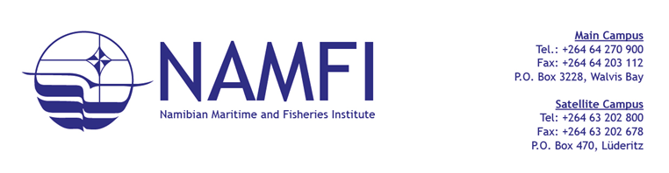
PROCUREMENT MANAGEMENT UNIT

NOTICE TO BIDDERS
BID CLARIFICATION NOTICE- ON IMMERSION SUIT BID
TO ALL BIDDERS
The Namibian Maritime and Fisheries Institute hereby issues the following clarification in response to queries received regarding the following bid:
Bid Name: Supply and Delivery of Safety Immersion Suits
Bid Reference No.: G/RFQ/NAMFI-15/2026
BIDDER’S CLARIFICATION REQUEST | THE INSTITUTE RESPONSE
Request for the following information regarding the Immersion Suits:  Query 1: Delivery Lead Time for Specified Immersion Suits  - The Bid Document specifies the Inherently Buoyant Immersion Suit PS2007 and the No-Buoyant Immersion Suit PS2014, which are both products associated with the Viking brand. Based on information obtained from the manufacturer and suppliers, the standard production and delivery lead time for those suit is  Approximately 10-14 weeks.  - However, the RFQ indicates that delivery is required within 21 days from acceptance of the bid award, Unfortunately meeting this delivery time frame with the specified Viking models would not be feasible sue to the manufacture’s lead time  Query 2: Brand Specification and Market Competition  - In addition, we understand that there is currently only one authorized retailer for the Viking brand in the Namibian market, which may unintentionally limit competition and create a monopoly situation for this procurement  Query 3: Submission of Alternative Brands  - In Light of the above, we would like to kindly enquire whether alternative brands of immersion suits may be quoted, provided that they fully meet or exceed the technical specifications outlined in the tender document. Allowing equivalent product s could help ensure competitive participation while still meeting the operational and safety requirements of the procurement.  Query 4: Acceptance of Equivalent Products  - We will appreciate your guidance on where such alternatives would be considered acceptable under this RFQ | - The Procuring Entity acknowledges the concern raised regarding the delivery lead-time. In order to accommodate market conditions while maintaining procurement timelines, the delivery period has been revised from 21 days to 4 weeks (28 days) from the date of acceptance of the bid award.  - In line with the principles of fairness, transparency, and competition provided for in the Public Procurement Act, 2015, technical specifications should not unnecessarily restrict competition. Where a brand name is mentioned in the specification, it should be interpreted as “or equivalent.  - Yes. Bidders may submit equivalent products, provided that such products fully comply with or exceed the technical specifications and operational requirements stated in the RFQ. Bidders must submit supporting technical documentation, product specifications, and relevant certifications to demonstrate compliance.  - Equivalent products will be considered acceptable, provided they fully comply with the specifications and performance requirements stated in the bidding document..
Important Notice:
This clarification notice forms an integral part of the bidding documents and must be acknowledged by all bidders. However, failure to acknowledge receipt of this notice will not result in disqualification.
Bid Submission Deadline: 18 March 2026
Bid Closing Times: 14H30
Submission Address: Namibian Maritime and Fisheries Institute,
1st Street East, No. 29, Next to Old Naval Base, Walvis Bay, Namibia
Bid Box located at the Reception
NB: BID DOCUMENTS ARE AVAILABLE ON THE NAMFI WEBSITE: www.namfi.net
LATE BID WILL NOT BE ACCEPTED
GENERAL ENQUIRIES:
NAMFI Procurement Management unit: procurement@namfi.net or +264 64 270900

