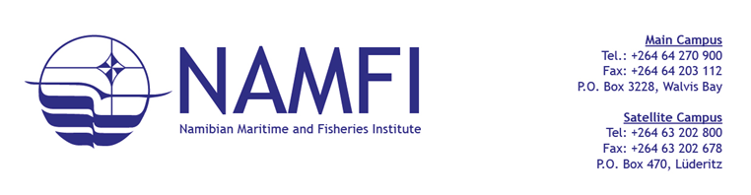
PROCUREMENT MANAGEMENT UNIT

NOTICE TO BIDDERS
BID CLARIFICATION NOTICE- SAFETY PROTECTIVE CLOTHES AND CORPORATE WEARS

TO ALL BIDDERS
The Namibian Maritime and Fisheries Institute hereby issues the following clarification in response to queries received regarding the following bid:
Bid Name: Supply and Delivery of Safety Protective Clothes and Corporate Wears
Bid Reference No.: G/RFQ/NAMFI-18/2026
BIDDER’S CLARIFICATION REQUEST | THE INSTITUTE RESPONSE
Request for the following information regarding the Immersion Suits:  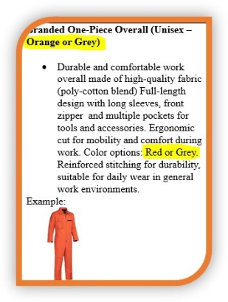 | The Procuring Entity wishes to bring to the attention of all bidders that the Bid Document contains an inconsistency in the colour specification for the Branded One-Piece Overall (Unisex). The document indicated the colours as “Orange or Grey” in one section and “Red or Grey” in another section.  Please note that this was an administrative oversight.  The correct and required colour for the overalls is Orange only. Therefore, Grey and Red will not be accepted.  All bidders are requested to submit their quotations based on Orange overalls only.
Important Notice:
This clarification notice forms an integral part of the bidding documents and must be acknowledged by all bidders. However, failure to acknowledge receipt of this notice will not result in disqualification.
Bid Submission Deadline: 18 March 2026
Bid Closing Times: 14H30
Submission Address: Namibian Maritime and Fisheries Institute,
1st Street East, No. 29, Next to Old Naval Base, Walvis Bay, Namibia
Bid Box located at the Reception
NB: BID DOCUMENTS ARE AVAILABLE ON THE NAMFI WEBSITE: www.namfi.net
LATE BID WILL NOT BE ACCEPTED
GENERAL ENQUIRIES:
NAMFI Procurement Management unit: procurement@namfi.net or +264 64 270900

